Mega Pixel PowerView PTZ Camera (MPV)
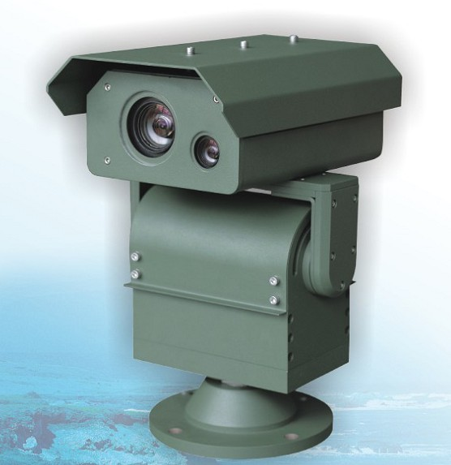

PowerView Laser-IR Pan/Tilt Series are integrated with a day/night camera module (18x/ 23x/ 26x/ 30X/ 35x/ 36x 530TVL - optional), adjustable laser-IR and geared pan/tilt controller. The PowerView body is machined with an A3 armor iron panel, plus with the resistant sealed design, can effectively prevent damage from the outdoor environment.

PowerView Laser-IR Pan/Tilt Series has a built in 808mm long distance adjustable Laser-IR illuminator. In a completely dark environment, it can identify a human target within 200 meters, and discover the target within 300 meters. It’s an ideal choice for daytime surveillance. For its own unique omni-seal waterproof design and night vision features, it is tailor made for use in low light and in total dark environments.
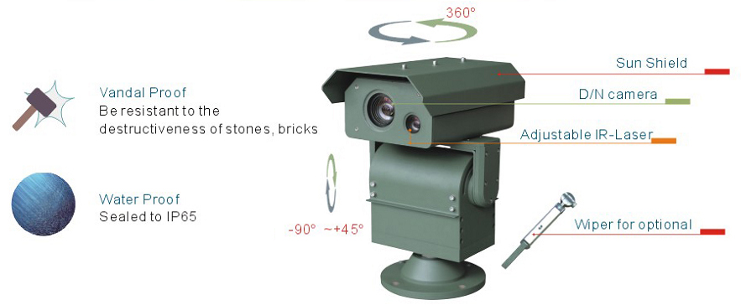
- Integration of Day/Night Camera, adjustable IR Laser, receiver, variable PTZ Controller and enclosure
- PV series are machined from the mixed A3 armor plate, coupled with its unique sound and solid dome body design, it efficiently prevents from any destructiveness that might threaten in normal use.
- Flat designed optics window from filmed and toughened glass (5mm thick) offers distortion free image and maximum vandal resistant protection for IOP (Integrated Optical Package) camera module
- Unique DIP switch design, offers easy of use
- Motor calibration in manual or auto guarantee preset precise continuous running
- Alarm box and water pump system - optional
- IP66/CE/FCC/RoHS compliance
- Support with LeadEx firmware online remote upgrade module
- Optional Built-in IP module

- Built-in Sony or Hitachi IOP camera module
- Back light compensation on/off selectable & WDR functions
- 8 Privacy Masking Zone and OSD password protection (Please see the camera parameters)

- Built-in the 808nm long distance Laser-IR illuminator with light power 2000mw
- Laser ON/OFF by manual or auto control optional

- OSD password protection
- User definable 128 target presets, 8 preset tours, video frozen
- Programmable Pattern & auto scan
- User definable power-up action and temperature control
- User definable left and right limitation, proportional Pan speed
- RS-485 communication port, RS-232, RS-422 for optional
- Compatible to Pelco P/D protocol and customized protocol - optional
- Auto / Manual zero calibration
- OSD programming menu, inside temperature and pan/tilt/zoom position
- Surge & non-volatile protection

- Machined from the mixed A3 armor plate
- Filmed and toughened glass: 5mm
- Continuous working temperature：-20°C -- +50°C
- Storage temperature: -40°C -- +60°C
- Net weight: 5KG
- Dimension: 250 x 301.2 mm (L*W)
- Packing Volume: 42x 32 x 28 cm

- Input voltage: AC24V, 50HZ
- Maximum Power: 72VA (Laser ON)

- Pan/tilt speed: Pan 0.23°~95°/s Tilt: 0.09 ° ~ 40° /s
- Preset speed: Pan 95° /s Tilt ：40 ° /s
- Preset accuracy: +/- 0.03° (auto /hand control.)
- Auto scan: 1°-40°/s
- Pan rotation: 360° Tilt rotation: -90° ~+45°
- Laser electric current: Average 245mA
- Laser working voltage: Average 2050 mV
- Slope efficiency: Average 1.20
- Laser wavelength: 808nm （Please see the Laser spectrogram）
- Electric working electric current: 2000mA
- Electric light efficiency: 2000mW
- Laser Angle: 1° ~8°
Laser electric current- Power Consumption Specification chart
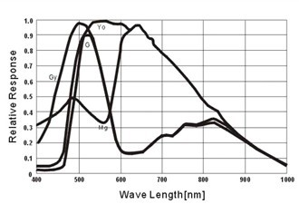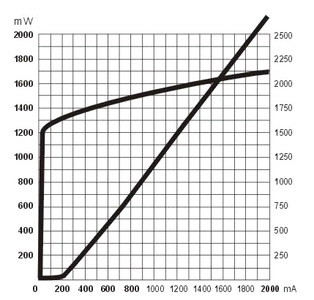
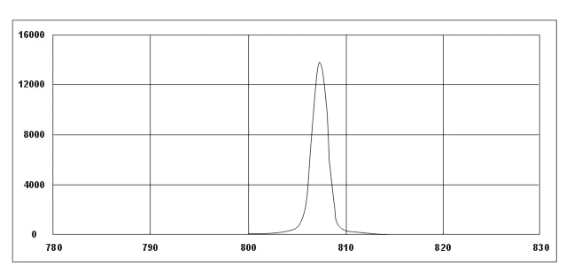
The typical applications include: marine transportation, military foundation, perimeter protection, ammunition depot, jails, ports, nuclear facility, Oil refineries, rigs, offshore drilling platform, oil and gas stations, chemical plants, embassies, airports, city surveillance, government, banks and vehicles (off-road vehicles, police cars, military vehicles) etc.
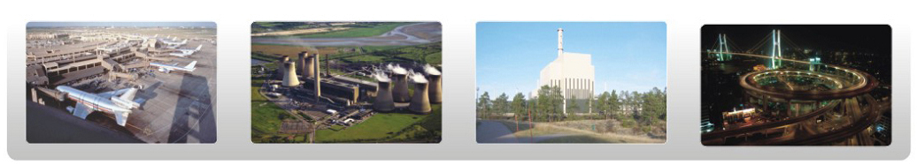

Dark night outdoor testing for PowerView IR Series Performance(o LUX)
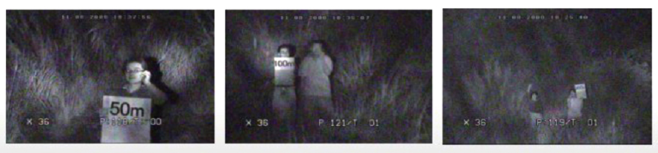
Outdoor illumination <0.1 Lux
The distance is about 100meters between the Laser IR PowerView and the target with the red mark
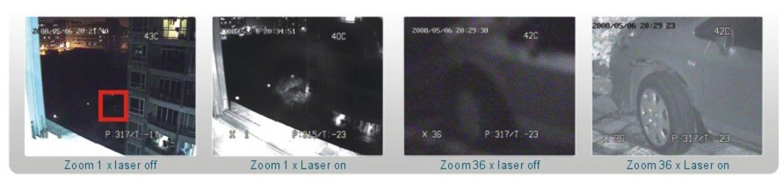
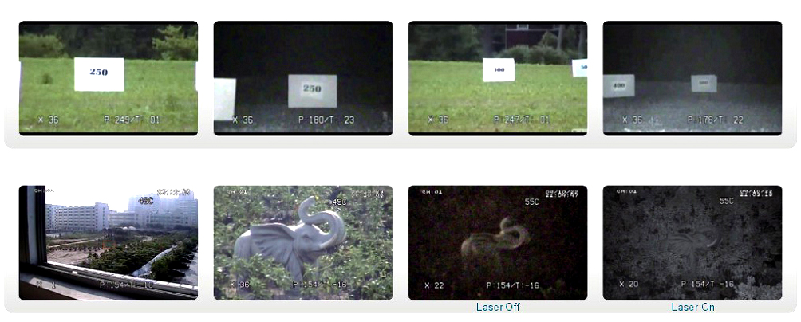
IOP Camera | SONY |  |  | HITACHI
Model Number | PV-18S | PV-26S | PV-36S | PV-23S | PV-30S | PV-35S
Model Number | FBC-EX480/490 | FCB-EX980/990 | FCB-EX1000/1010 | VK-S858 | VK-S634 | VK-S654

